|  |  |  |  |
| --- | --- | --- | --- |
| Adjective | Comparative | Superlative |  |
| 1. talkative |  |  |  |
| 1. tall |  |  |  |
| 1. good at |  |  |  |
| 1. friendly |  |  |  |
| 1. hard-working |  |  |  |
| 1. funny |  |  |  |
| 1. old |  |  |  |
| 1. comfortable |  |  |  |
| 1. young |  |  |  |
| 1. big |  |  |  |
| 1. small |  |  |  |
| 1. long |  |  |  |
| 1. short |  |  |  |
| 1. generous |  |  |  |
| 1. sporty |  |  |  |
| 1. beautiful |  |  |  |
| 1. handsome |  |  |  |
| 1. messy |  |  |  |
| 1. fast |  |  |  |
| 1. dangerous |  |  |  |
| 1. intelligent |  |  |  |
| 1. strong |  |  |  |
| 1. nice |  |  |  |
| 1. polite |  |  |  |
| 1. kind |  |  |  |
| 1. expensive |  |  |  |
| 1. boring |  |  |  |
| 1. exciting |  |  |  |
| 1. easy |  |  |  |
| 1. difficult |  |  |  |
| 1. dark |  |  |  |
| 1. quiet |  |  |  |
| 1. clean |  |  |  |
| 1. interesting |  |  |  |

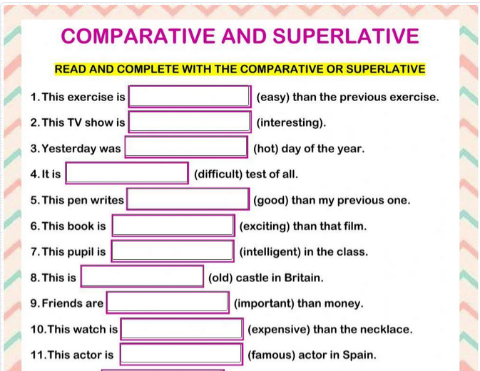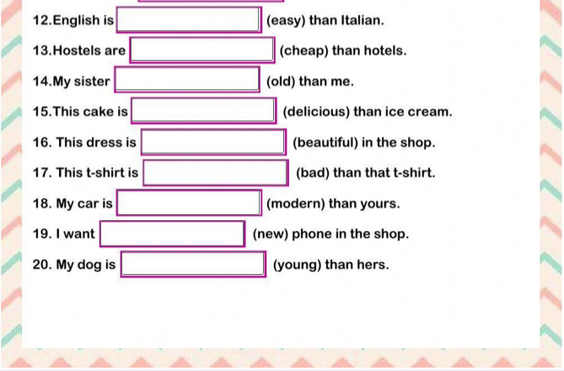

A**. Fill in correct words:**

1. Are you better at maths ________your friend?
2. Are you________ talkative than your friend?
3. Could you speak _____________ (slow), please? I don't understand you.
4. Is your bag ____________(big) _______ your friend’s?
5. Who is ______________ (tall) student in the class?
6. Who’s got ____________( long) hair in the class?
7. Are you ___________ hard-working than your friend?
8. Our climate is getting ___________ and ____________ . (warm)
9. This tea tastes a bit ______ (sweet) ______ the other.
10. Are you older _________ your friend?
11. I'm trying to do it ___ ___________(fast) ___ I can.
12. Who is ____________(old) person in your family?
13. Who’s __________________ (pretty) person in your family?
14. **Hi Suzan,**

I'm having a wonderful time in Los Angeles. The weather is.............. (hot)

and drier ................ (as/than/that) in England and Americans are friendlier than ................ (us/we/our) . The food is better here; it's not the same ................ (as/than/that)  the food in England at all! From all the countries I've been to, I think English food is the ................ (more/less/least)  pleasant. It's awful. Yesterday I had the best hamburger I’ve ................ (ever/never/before) eaten! The hotel is beautiful. I think it’s not as ............ (nice) ...........

the hotel we stayed in New York, but it's ................ (much more/lot more/most)  comfortable. They say that Los Angeles is one of the most expensive cities ................ (in/of/from) the world, but actually, I'm not spending ................ (as much/as many/more) money as I thought. I’ll phone you when I get back.

Love,  
Megan.

1. **Fill in:**

1 This exam was  **(easy)** than the exam in May.

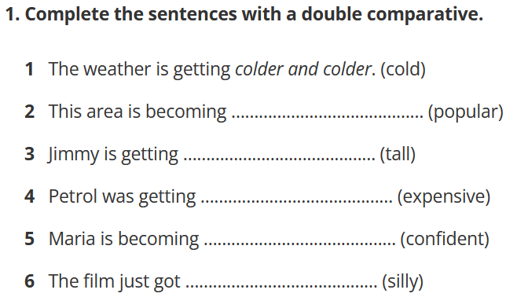2 You should drive **(slowly)** or you'll have an accident.

3 My new home is **(near)** from work than the old one.

4 The test wasn't as **(difficult)** as I thought.

5 This is the **(far)** place I've ever travelled to.

You look much **(thin)** than the last time I saw you.

7 My new computer is a bit **(good)** than the old one.

8 September is the **(busy)** month of the year for us.

9 There are **(few)** people today because it's been raining a lot.

10 The  **(tricky)** part of the exam was the listening.

**D. Put the words in the correct order.**

**1** I thought / longer / The journey was / than

**2** more spacious / The flat was / than / appeared / it

**3** in Greece / hotter / it was / The weather here is / than

**4** much more / it used to be / The house is / destroyed / than

**5** than / My grandad is / when he was a young man / shorter now

**6** as popular as / it was / five years ago / This area isn’t

**E. Complete the sentence halves with the comparative form of the adjectives and adverbs in brackets. Then match 1-5 with a-e.**

**1**  The ………………………………… (long) I work,

**2**  The ………………………………… (spacious) the house,

**3**  The ………………………………… (fast) you drive,

**4**  The ………………………………… (carefully) you check your work,

**5**  The ………………………………… (long) you keep him waiting,

**a**  the ………………………………… (expensive) it will be.

**b**  the ………………………………… (impatient) he’ll become.

**c**  the ………………………………… (few) mistakes you make.

**d**  the ………………………………… (likely) you are to have an accident.

**e**  the ………………………………… (tired) I feel.

**F. Complete the sentences with** less, the least, fewer, **or** the fewest**.**

**1** The kitchen is ………………………… spacious room in the house.

**2** My flat is ………………………… conveniently located than yours.

**3** This house has got ………………………… rooms of the three we’ve looked at.

**4** Which costs …………………………, the semi-detached house or the terraced house?

**5** This is ………………………… popular area of the city.

**6** Which room has got ………………………… furniture, the dining room, living room, or kitchen?

**7** There are ………………………… flowers in the flower bed this year than last.

**8** Wales is ………………………… remote than the north of Scotland.

**G. Complete the sentences with the comparative and superlative form of the adverbs in brackets.**

**1**  Dan drives ………………………… than Ed, but Sam drives ………………………… of all. (slow)

**2**  Amy works ………………………… than Kate, but Frances works ………………………… (hard)

**3**  Adam speaks French ………………………… than Jason, but Chris speaks ………………………… (fluently)

**4**  Jed walks ………………………… than Fred, but Tom walks ………………………… (fast)

**5**  Ed writes ………………………… than Fran, but Susan writes ………………………… (good)

**H. Complete the sentences with the correct form of the adjectives in brackets. It may be necessary to add an extra word to the sentence.**

**1**  The ………………………… the house, the more expensive it is to heat. (large)

**2**  That’s the ………………………… balcony I’ve ever seen. (tiny)

**3**  Houseboats are ………………………… today than they used to be. (common)

**4**  We’ll have to look ………………………… if we want to find a house we can afford. (hard) **5**  Our new flat has ………………………… rooms than our old one, so now I have to share a room with my sister. (few)

**6**  Your garden is ………………………… than ours because you haven’t got as many flowers. (colourful)

**7**  They’re worried that their cellar might flood as it’s raining ………………………… now. (heavy)

**8**  This is the ………………………… room in the house because we haven’t furnished it yet. (comfortable)

**9**  The grass on their lawn is growing ………………………… and …………………………, but nobody seems interested in cutting it. (high)